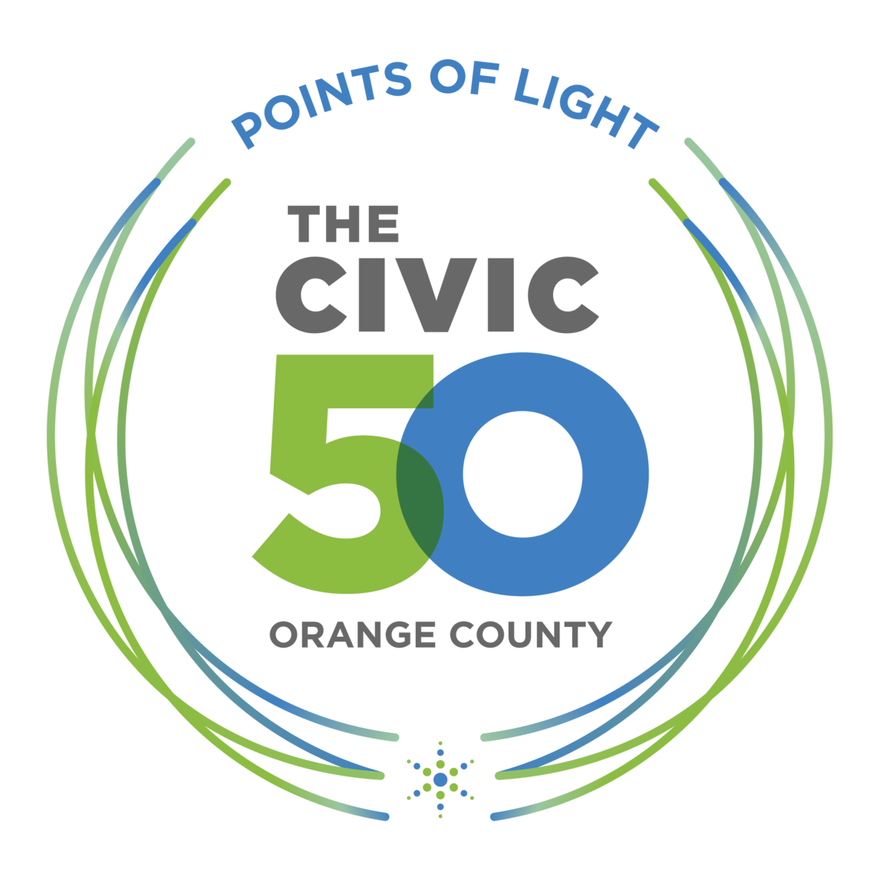
The Civic 50 Orange County Questionnaire
Name:

Company Name:

Title/role:

Email:

Phone:

City:

Employees in Orange County:

Employees Company wide:

How does your company share its resources in your community?
 | Not doing this now | Informally and occasionally  1 | 2 | 3 | 4 | Formally and we have a strategy  5
Hands on volunteering in the community
Skills-base and
pro bono volunteering
Cash donations, grants and sponsorships
In-kind contributions (goods, services, space)
Advocacy

Are other parts of your business also supporting your community and social values?
 | Hadn’t thought about it | Informally and occasionally  1 | 2 | 3 | 4 | Formally and we have a strategy  5
Purchasing and sourcing of materials and services
from local, minority or women owned businesses
Marketing and sales efforts support our social values and causes
Recruiting, hiring and developing employees

How does your community-focused culture shine throughout your company? Select all that apply:
- In our business mission, company values and goals
- In employee performance reviews
- In our employee handbook or other HR materials
- In team meetings
- Through our internal messaging boards or online channels
- Social and community issues are regularly on our board or partner meeting agenda
- Our founders and owners speak up on social and community issues
- Other (please specify)

What community engagement programs and opportunities do you offer employees? Select all that apply:
- Team volunteering and service activities
- Skills-based/pro bono volunteering opportunities
- Paid time off to volunteer
- Connect employees to community leadership opportunities and nonprofit board service
- Bring in guest speakers or trainings on social issues
- Other (please specify)

How do you support voting and civic engagement for employees and customers? Select all that apply:
- Ballot drop boxes
- Census participation promotion
- Informational events/town halls at our business
- Issue workshops and training
- Paid time off to vote
- Share voting and registration information (customers)
- Share voting and registration information (employee)
- Other (please specify)

Are you tracking what happens when you engage in community? Select all that apply:
- Not thinking about it
- We talk to our community partners
- We track how much time/money we give
- We check in at least once per year to see what our nonprofit partners need
- We survey our community partners at least once per year

Are you tracking what happens to your business when you engage in community? Select all that apply:
- Not thinking about it
- We talk with our business partners and vendors about our civic and social issue efforts
- We invite customers to join our civic and social efforts
- We talk with prospective or existing customers/clients about our civic and social issue efforts
- We make time and space for employee feedback about their engagement experiences
- We survey our employees about their engagement experiences

Please share other ways that you have supported and engaged your community (optional)

How would you like to do more for your community? (optional)

Take the Next Step!

- Take The Civic 50 Orange County!
- Join the Community for Employee Civic Engagement (CECE) – an online platform for CSR and community engagement resources, reports and news
- Explore the Social Impact Guide – a free actionable online guide with tools, strategies and resources for community engagement practitioners and purpose-driven professionals

